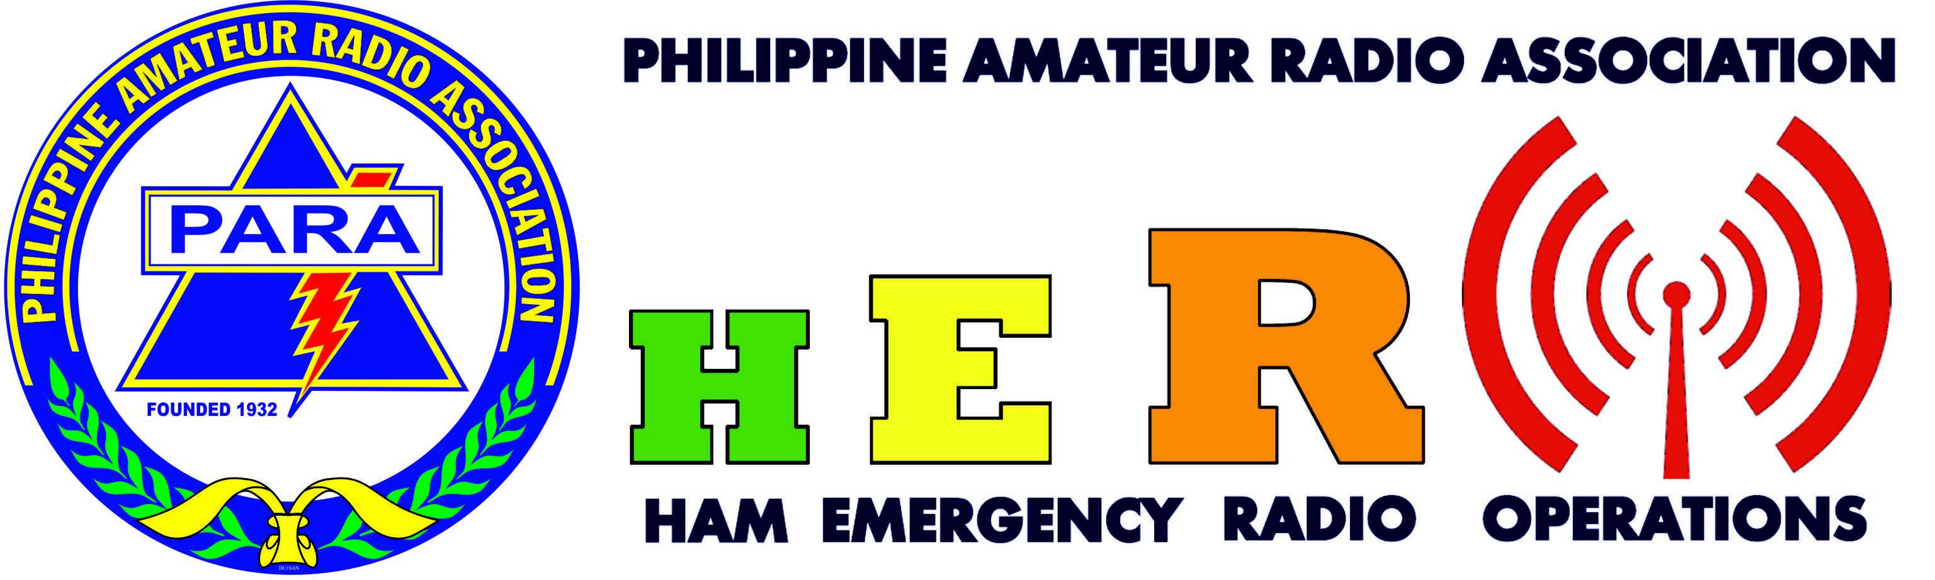

2nd PARA HAM RADIO GO-KIT CONTEST
REGISTRATION FORM

NAME ________________________________________ CALLSIGN _______________
CLUB ________________________________________ PARA ID No. _______________

CATEGORY : HT or Mobile VHF or V/U or Mixed

HF +

TRANCEIVER/S : __________________________________________________________

ANTENNA : __________________________________________________________

Power Supply : Battery Wind

Solar Others : _______________________

_____________________________________
Signature over printed name

IMPORTANT:

- All transceivers used in the Go-Kit must be licensed. ARSL shall be presented during the competition.

- Submit this form on or before Nov. 27, 2016 to the PARA Secretariat or via email address para1932@gmail.com

